**Accounting Analytics**

**1. List all the audit risks (fraud and non-fraud) with respect to these files.**

Fraud risks

* The supplier/customer physical street address could be falsified
* On the Purchase Orders sheet, the same person could be entering the transactions and approving them, creating an opportunity for fraud.

Non-Fraud risks

* Payment amounts could have been mis-reported
* Some orders had errors and weren’t placed, however there is a chance they were still accidentally paid for.
* Like any audit, there are also factors such as inherent, control, and detection risk.
  + Inherent risk is related to how the company operates and its business environment.
  + Control risk is related to the effectiveness of a company’s internal controls.
  + Detection risk is related to the risk of actually identifying fraud if it is present.

**2. What test(s) would you perform to address these risks? Describe in detail.**

The name on the street addresses of suppliers and customers can be cross referenced with the list of employees to potentially detect fraudulent activity in this regard.

The name of the person entering the transactions on the Purchase Orders sheet can be cross referenced with the name of the person approving the transaction. Any instances where the same name is found on a single transaction would indicate that this transaction should be investigated further for possible fraudulent activity.

The invoice number on the purchase orders sheet could be cross referenced with the invoices received sheet to ensure that transactions have matches and that the values entered match.

Match the goods received status to the payments sheet to make sure that orders which generated errors weren’t paid if the goods were never received. Similarly, you could make sure that the orders that were successfully placed were all paid.

**3. Complete Lab 6-1 in Excel ONLY. Answer ALL questions.**

**Q. Given what you know about the vendor address, what types of address would be the most suspicious?**

The most suspicious addresses would be the ones that occur frequently in the data. For instance, you would not expect this company to have a lot of suppliers from the same area. Why would they need 6 suppliers from the same town? As such, any supplier locations that repeat too frequently should be investigated further.

**Q. How could a vendor be added to an enterprise system with a suspicious address?**

A vendor could be added to an enterprise system with a suspicious address if

* There is no cross checking of the added addresses
* Process of entry and audit is not well defined i.e. the same person is entering and auditing the addresses.
* The enterprise system lacks address validation feature or it can be overwritten easily by the person who is entering the data

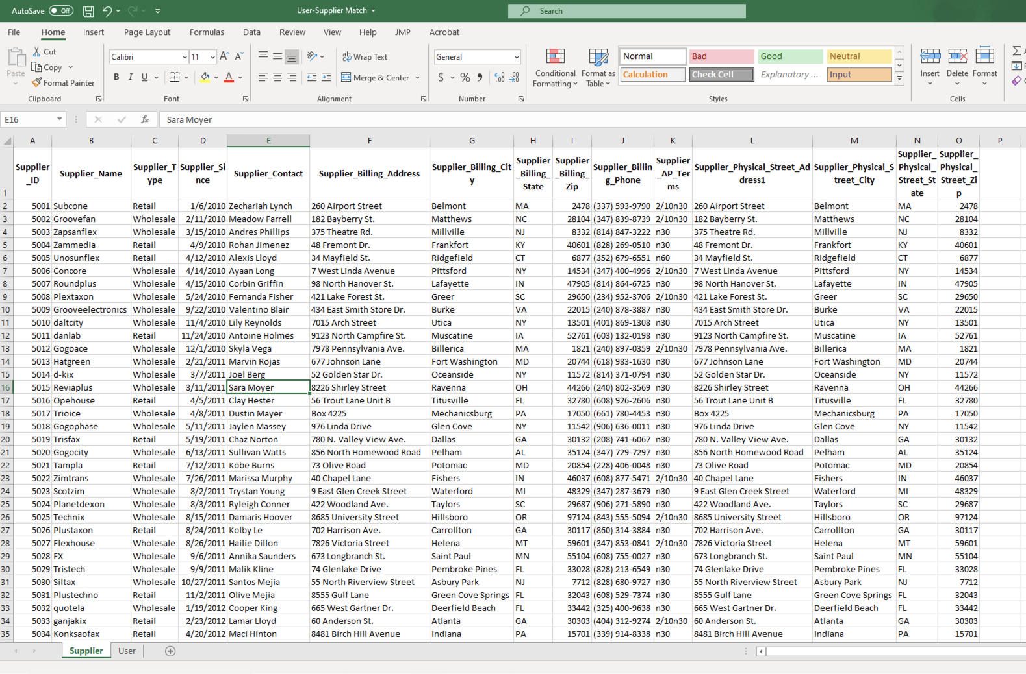

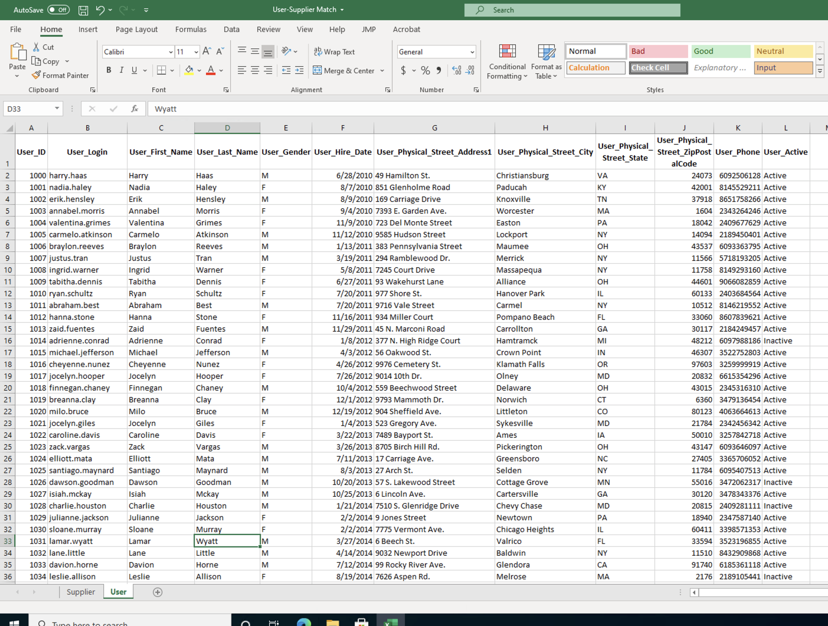

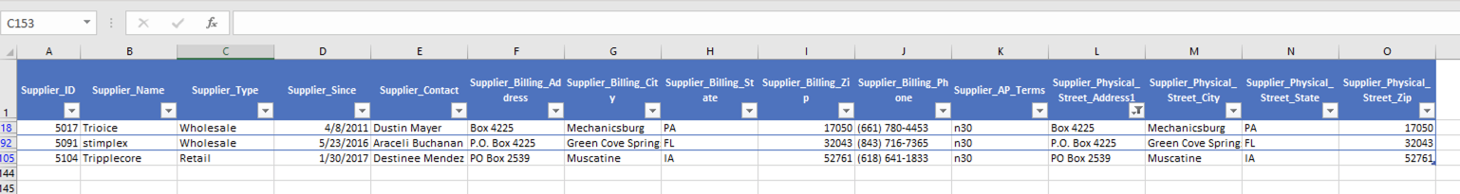

**Q. How Many PO Box addresses appear?**

3

**Q. Why should you follow up on PO Box addresses?**

Since PO boxes are established at the bank, the address wouldn’t match any of the employee addresses. These PO box addresses have a higher detection risk, meaning that there is a higher risk of not identifying these addresses as suspicious since they wouldn’t match employee addresses. When there is greater detection risk, a higher degree of caution should be used.

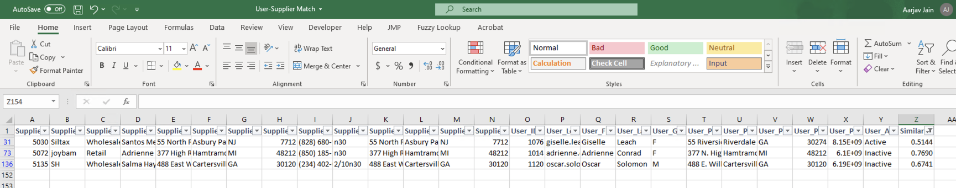

**Q. How many Fuzzy Similarities appeared?**

3

**Q. Which of the matches are suspicious?**

Supplier_ID 5072 - User_ID 1014

Supplier_ID 5135 - User_ID 1120

Because both users are **In-active.** Assuming that the inactive status is assigned to the used if there is no transaction from them for a certain period. This flags the supplier since and can be considered fictitious.

**Q. Which of the matches are normal?**

Supplier_ID 5030 - User_ID 1076

Because the user is **active,** assuming that the active status of the user means that he/ she is genuine and has been using the services on a constant basis. And thus the supplier provides them services and validates the existence of the supplier.

**Q. What are the limitations of the way you just evaluated addresses?**

The way we just evaluated addresses does not account for potential addresses that exist but are not entered in this database.

**Q. What other data values would indicate that there may be a fictitious supplier in the system?**

* Count of suppliers and users. If the suppliers are more than users this can indicate that either same user_id is used by more than one supplier, thus indicating that there may be a fictitious supplier

**4. Complete Lab 6-3 in Excel ONLY. Answer ALL questions.**

Q1.) Before data analytics, companies would most likely manually go through payment receipts to make sure that nothing had been paid prior to paying it. This ensures that duplicate payments are not made. Although, without computerization, this introduces a lot of room for human error.

Q2.) To identify duplicate payments, we would need the payment amounts, dates, and the invoices that the payments are related to. With this information we can search for payments of identical amounts on the same date, or similar dates, and then reference the invoice numbers to validate how much should be paid and when.

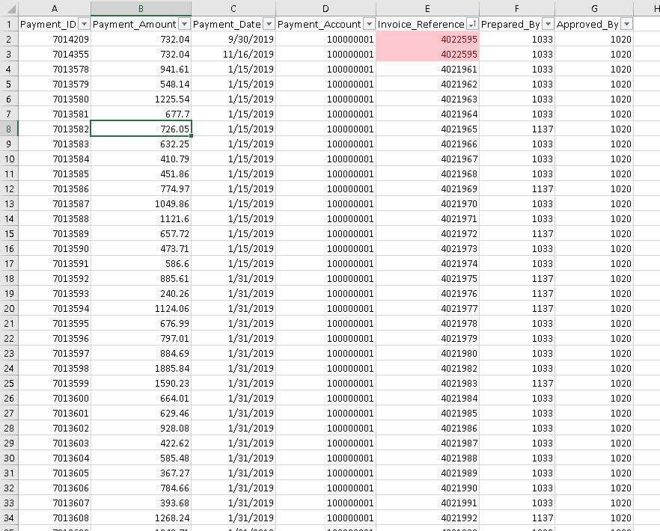

**5. Select 3 of the audit risks you identified above. Identify the questions(s) associated with each risk and perform the test plan(s) you described. Discuss the results and list additional questions your analysis might have generated. Please make sure you do not duplicate Lab 6-1 or 6-3 in this exercise.**

1. Is the person who entered the transaction different from the person who approved it?
   1. Who are the employees who are supposed to be approving? There is a chance that our test doesn’t identify issues if there are employees who aren’t authorized to approve transactions approving transactions.

Answer: Our test indicated a couple of interesting findings. Firstly, there is one transaction that seems to have no associated details with it (Payment_ID 7014094). Secondly, although it does not appear as though any single person both entered and approved any transaction, we found that only one person approves transactions. This poses obvious issues seeing as how this does not represent proper segregation of duties. There is too much power resting in this one individual.

1. Do the invoice amounts on the purchase order sheet match the payment amounts on the invoice received sheets?
   1. We can identify discrepancies, but we would likely need more information to determine which amount is correct.

Answer: After performing our analysis, we have determined that there are a few issues with the control systems in place with regard to the purchase orders and corresponding invoices. Based on our pivot table, we have found that there are quite a few transactions that generated invoices but were never subsequently paid based on the information in the Purchase Orders sheet. There were also a few manual errors such as amounts being transcribed incorrectly. For instance, invoice #4022021 was for $1,368.77 but the amount that the company paid was $1,386.77. This is a small amount of money in the grand scheme of things, but can add up to a lot in the long-run. The company should have IT application controls in place that detect inconsistencies like this; if the amount from the invoice does not match the amount that was paid, it should generate a list of these transactions for someone to review and follow-up on.

1. Are the goods received orders that generate errors actually paid?
   1. We can identify issues with controls here by comparing the goods received orders that were only partially filled or were not filled at all and see if the company disbursed cash for those orders. If the company is paying for goods that it never received, there is an obvious issue with that.

Answer: We found that all 8 orders that came up as ERROR were paid. This shows a clear lack of a control for ensuring that orders that are not received are not paid. The company is wasting money by not implementing this control because they aren’t receiving any product, yet they are paying for it.

**6. Can any of the risks and test plans you identified be analyzed in Tableau? If so, select 3, perform the analysis and discuss the results. If not, describe the limitations of the Tableau software.**

Non-Fraud risks: Payment amount could have been mis-reported. The following screen-shot show invoice numbers where the Invoice Amount is different from the Payment Amount.

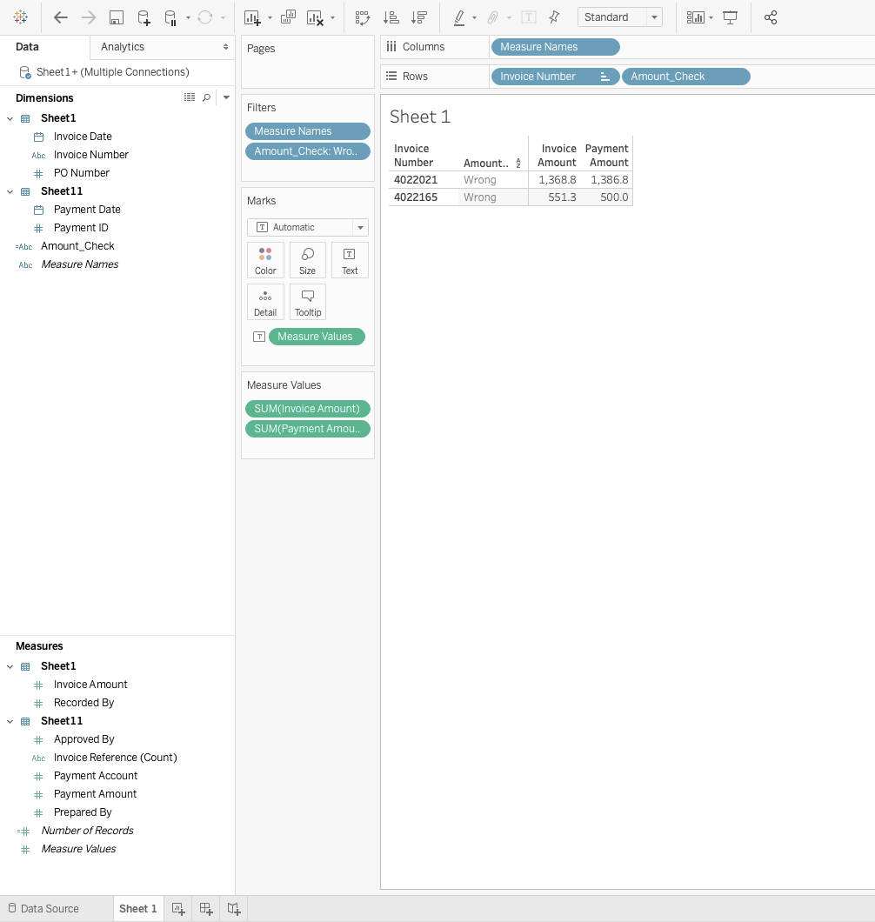

**Fraud Risk:** Checked whether Invoices were Prepared and Approved by the same person. Based on the analysis we couldn’t find such audit risk occurrences.

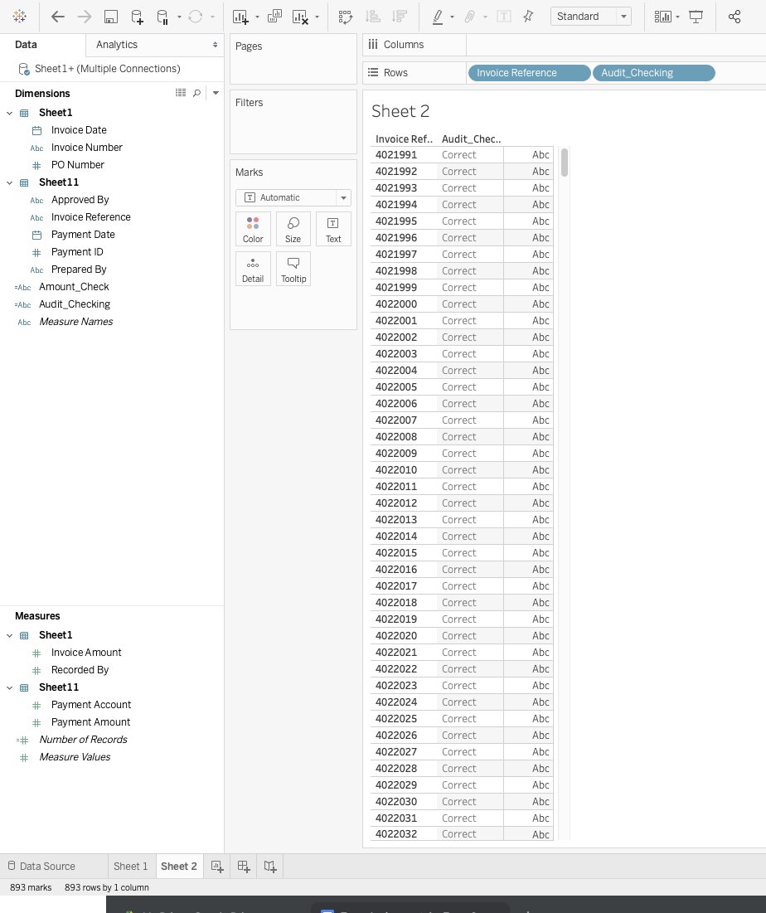

**Non-Fraud Risk:** Some Purchase Orders had errors and weren’t placed, however the payments were made for such orders. This could lead to fraud but to provide a detailed analysis we need to further analyze the order and find reason for the Error status.